SPRINGFIELD PUBLIC SCHOOL
KG
Name: Date:

Dear Parent
The summer Vacation for all classes have commenced from Monday, the students are encouraged to spend significant time in regular studies, Holiday home work for your ward is being sent to you.I would encourage every child to develop healthy reading habits in order to be relevant and smart.
Regards
ENGLISH

1. Write cursive small letters from a-z.

2. Write capital letters from A-Z.

3.
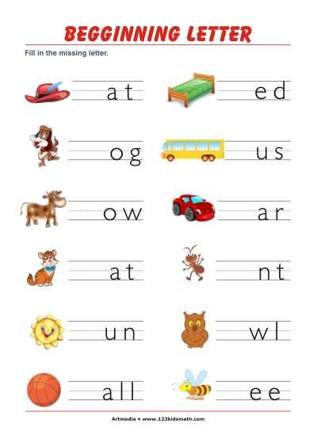
4. PHONIC ENDING SOUNDS. IDENTIFY THE ENDING SOUND AND WRITE THE WORD
5.
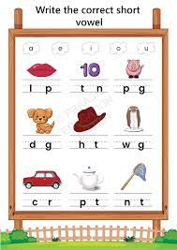
ACTIVITY
- MAKE YOUR CHILD LEARN HIS/ HER NAME, SURNAME, MOTHER’S NAME, FATHER’S NAME AND BIRTHDAY OF ALL AS WELL AS ANY ONE PHONE NUMBER.

- MAKE YOUR CHILD LEARN HOW TO DRESS UP AND TIE LACES.

- MAKE YOUR CHILD KNOW TABLE MANNERS TEACH THEM TO EAT ON THEIR OWN.

- TEACH THEM HOW TO PACK THEIR BAG.

- MAKE THEM ARRANGE THE LAYING THINGS AROUND AND PUT IT DOWN IN A PROPER PLACE.

EVS
1.
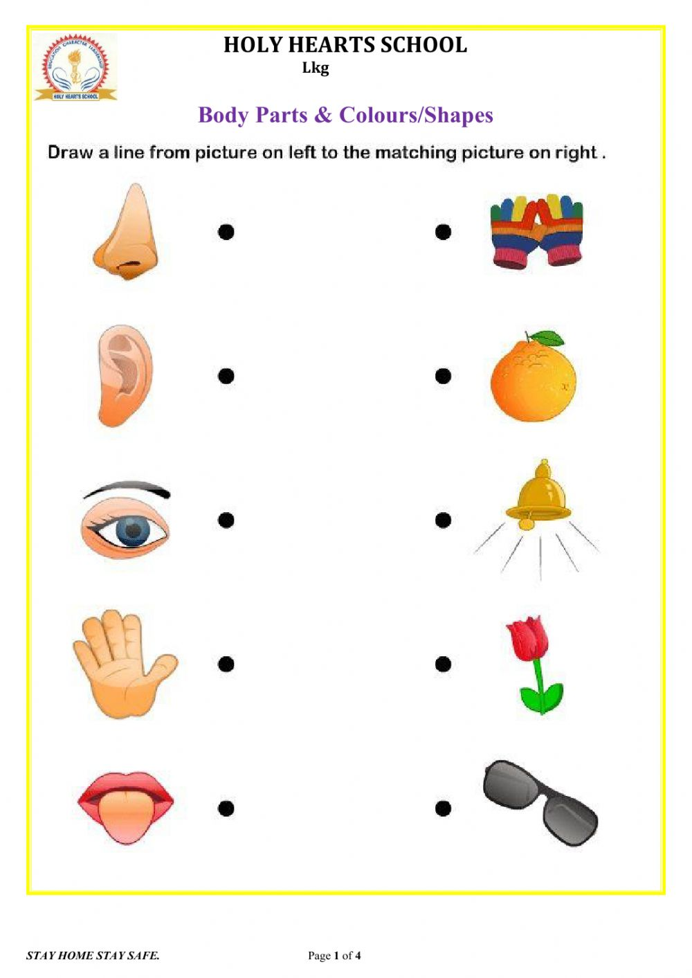
2.

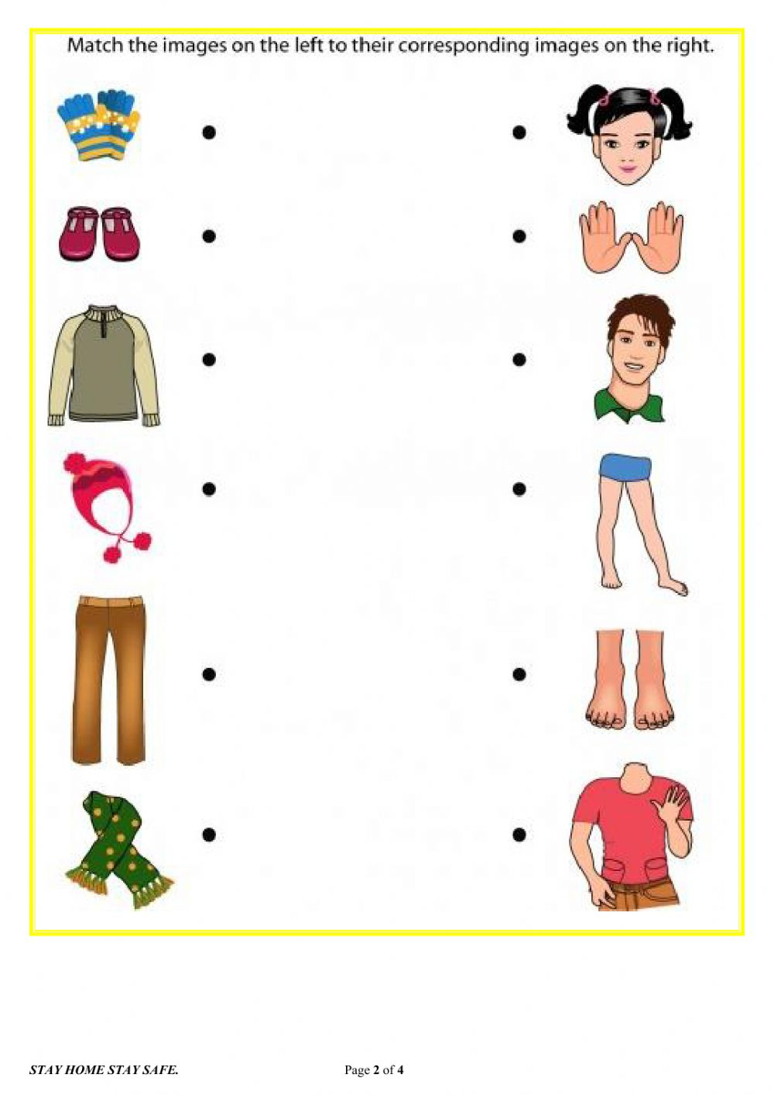

3.

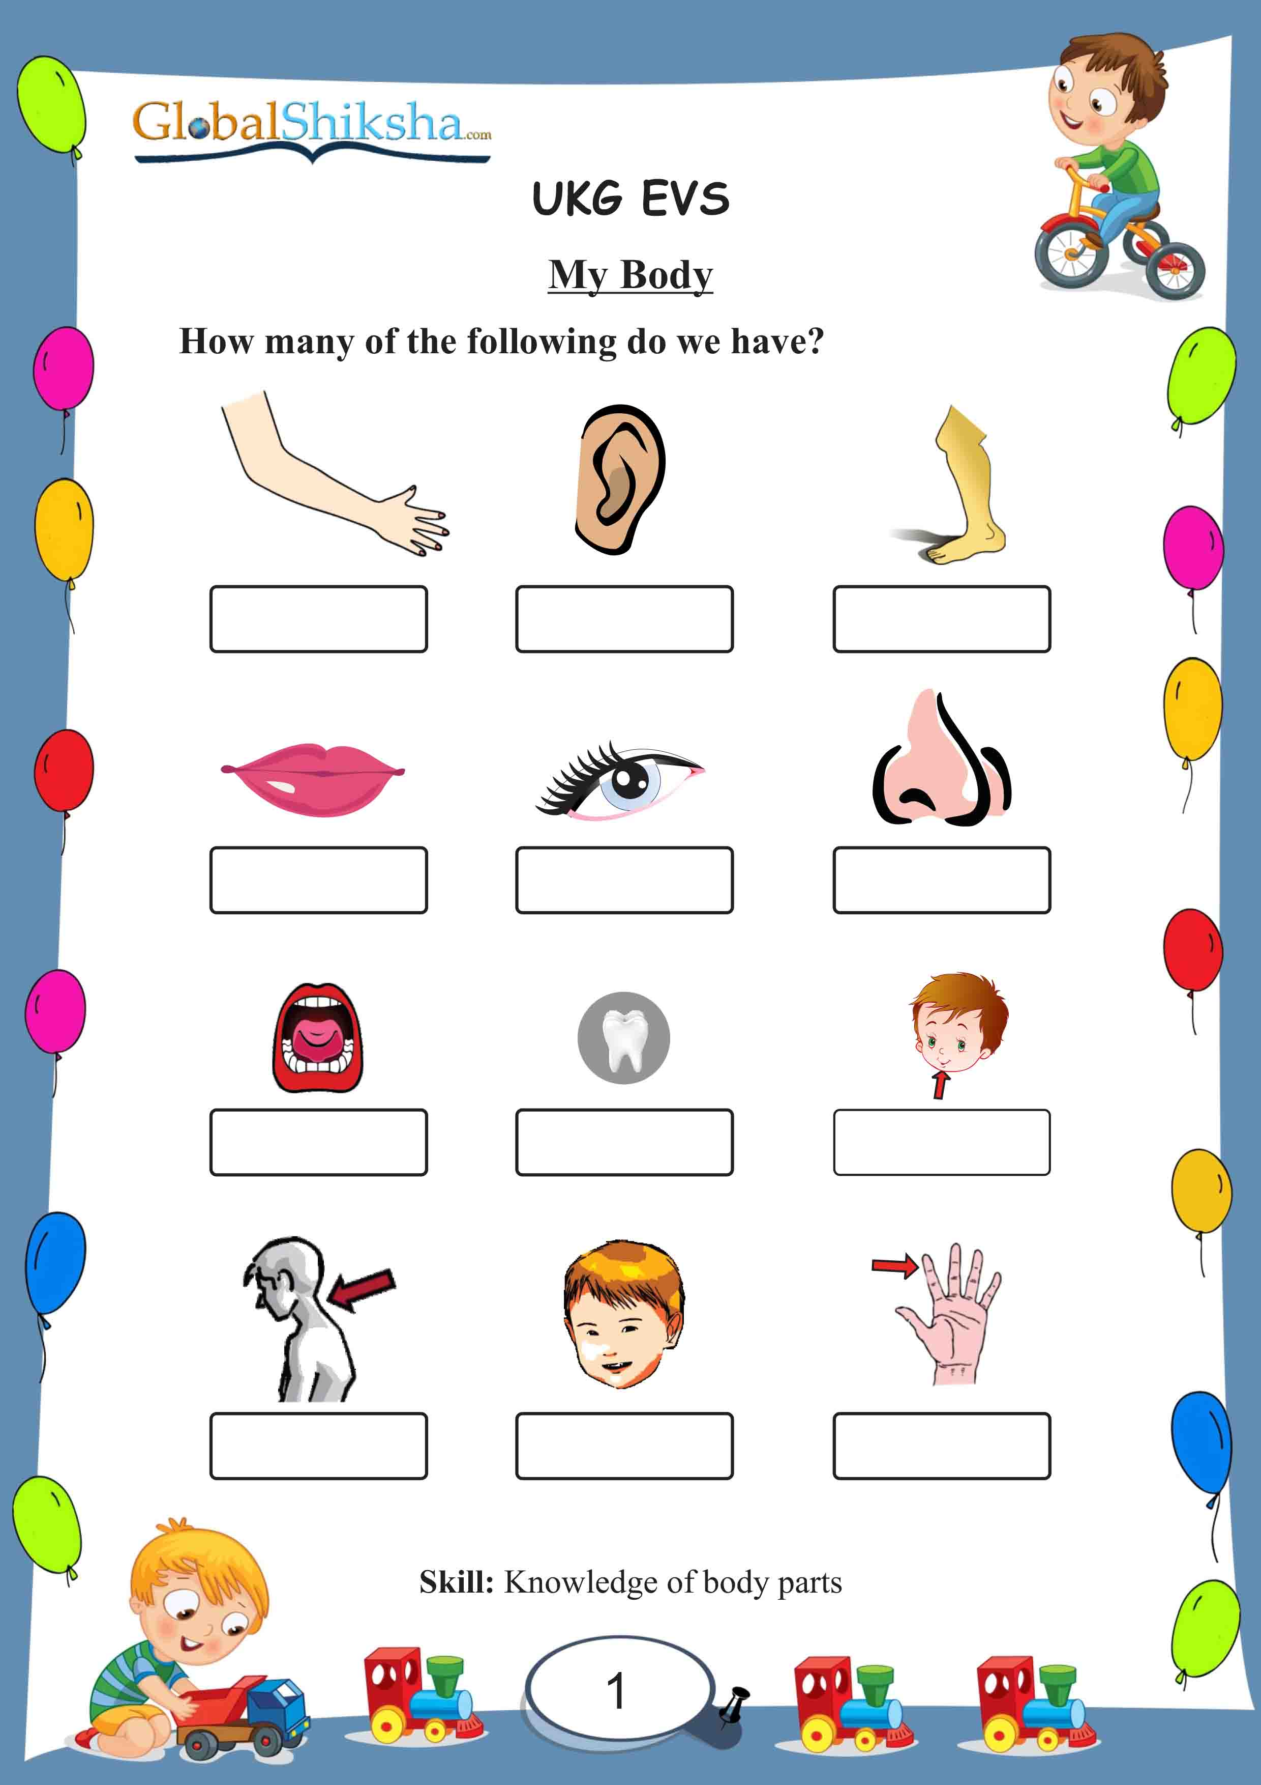
3.3.
4
4.
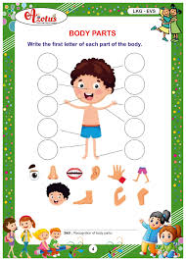
5.

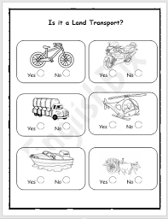
6.
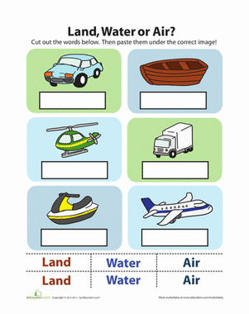
MATHS
- WRITE COUNTING 1-50
2.
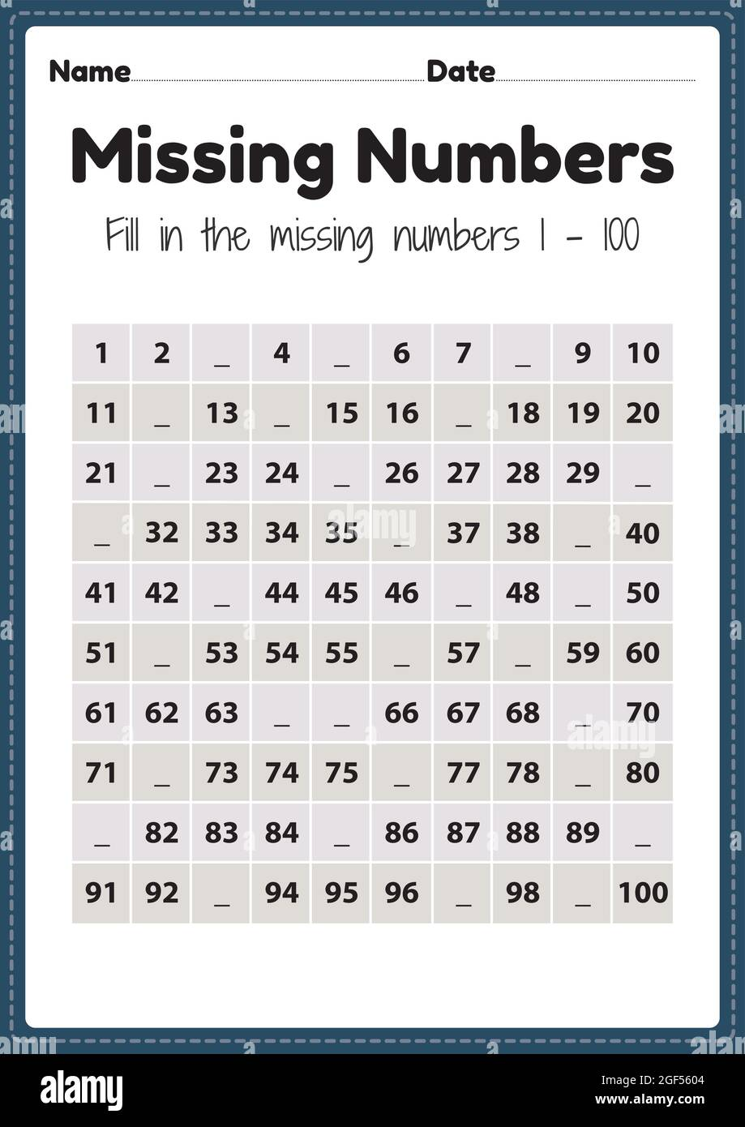
3. COUNT AND COLOUR THE CORRECT NUMBER
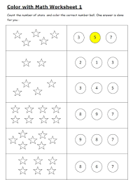
4.
5.
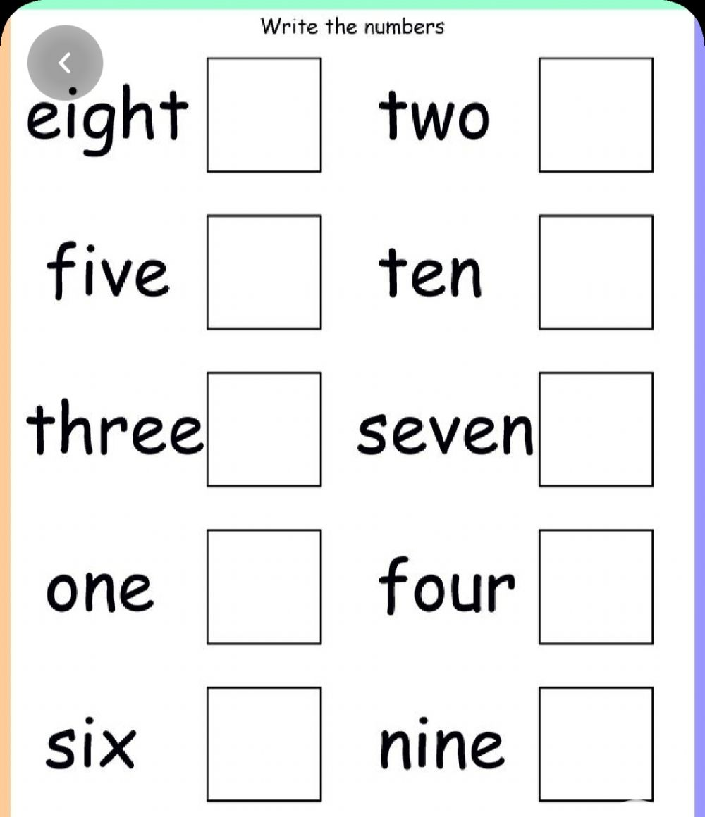
6.
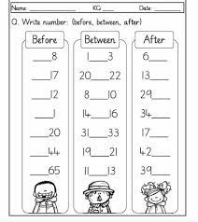

HINDI
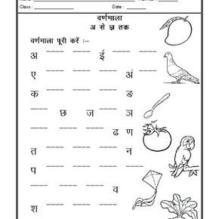

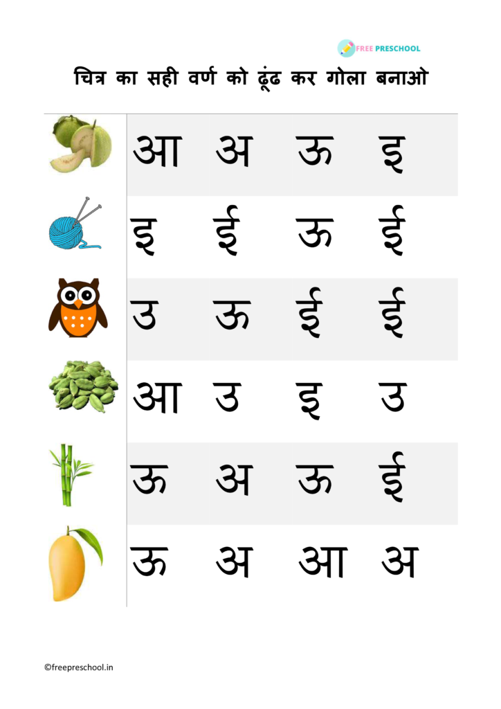
- निम्न लिखित को मिलाएं
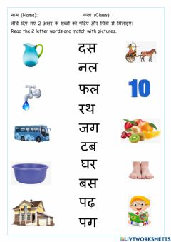

To be revised
English | Written-Capital A-Z, small print a-z, A-Z(after,before,between), a-z(after,before,between),  A-Z(Missing letters),a-z(missing letters),Matching uppercase letters to lowercase letters, Match the picture with correct three letter word(an,at,og,ot),Circle the correct beginning letter sound(a-  z),dictation(three letter ap,at,an,og,ot words),See the picture and write the first letter(A-Z)  Oral – Picture reading A-Z, Reading of three letter words(ap,at,an,og,ot)
Maths | Written – Forward Counting 1 to 50, Count and write the number  (1-20),Backward counting (10-1),missing numbers (1-50),after(1-20) , between(1-20),before(1-20) shape-oval,semicircle,square,rectangle,triangle,circle Pre math-tall/short, in/out, big/small, full/empty,heavy/light, Few/many,right/left  \Oral – forward counting 1-50,picture reading of shapes,picture reading of colours(red,yellow,blue,green,black,white),backward counting 10-1
Hindi | Written -स्वर (अ- अ:) , व्यंजन (क -ज्ञ) , चित्र पहचानकर सही अक्षर लिखे  ((अ- अ:) , (क -ज्ञ) ), अ शब्द(दो ,तीन,चार वर्ण वाले शब्द ), खाली स्थान भरे(अ- अ:) , (क -ज्ञ) ), चित्र देखकर सही अक्षर पर गोला लगाए ((अ- अ:) , (क -ज्ञ)  ) , ठीक मिलन करे (दो ,तीन चार वर्ण वाले शब्द)  Oral - दो ,तीन चार वर्ण वाले शब्द पढ़े , चित्रों के नाम पढ़े ((अ- अ:)
E.V.S | Written- (living room,bathroom,kitchen,bedroom, , vehicles on land,vehicles in air,vehicles on water, , indoor  games,outdoor games, Fruits,vegetables, wild animals,farm animals  All about me, good manners at home, parts of the body)  Oral-my favourite things (colour,fruit,toy,cartoon)  ,,introduction(name,gender,age,class,school name),parts of the body,good habits,magic words,good manners at home,picture reading ( my family,fruits name,vegetable name,wild animals,farm animals,indoor
 | games,outdoor games,vehicles on land,air,water )

