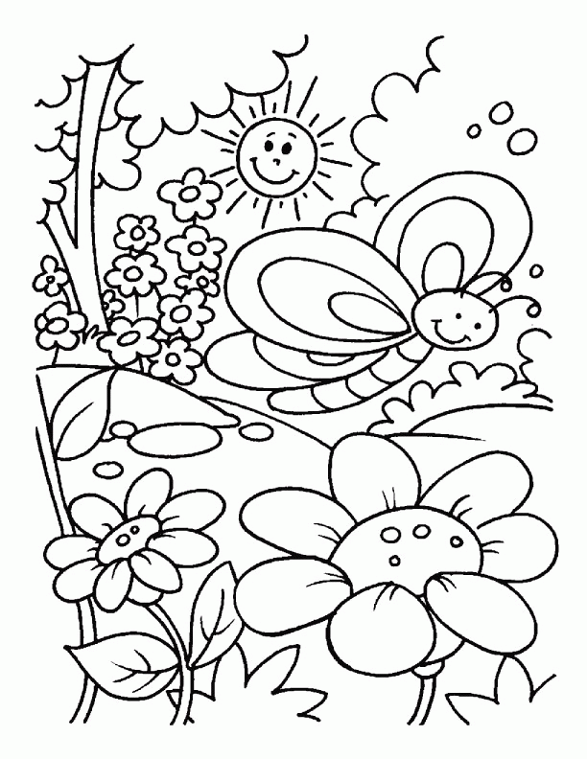
Enjoy your Summer
Colour Me!!!
Grade 1
FOR THE PARENTS

Summer is here,
It’s time to stretch your mind by reading books
It’s time to keep your body healthy by exercise
It’s time to grow closer to God by prayer
It’s time to help other by taking care of them.
Summer is here, Summer is here!

Dear Parents,
Holiday Homework is time for activity and fun. It is an opportunity to spend quality time with your little ones. Parents are requested to guide the children to complete the task on their own and also encourage them to read the story books.
Note:- Kindly prepare 3 in 1 notebook for holiday homework.
English - Learn the sight words given below.
Write 1 page English writing every day with date mentioned.

Hindi - Write 1 page Hindi writing every day with date mentioned.
Write and learn 3 words each from all the matrass.

Maths - Write and Learn the tables of 2 to 5.

Evs - Learn the lines about self-introduction.
Learn week names with spelling.

Note:- Learn all the work done till now.

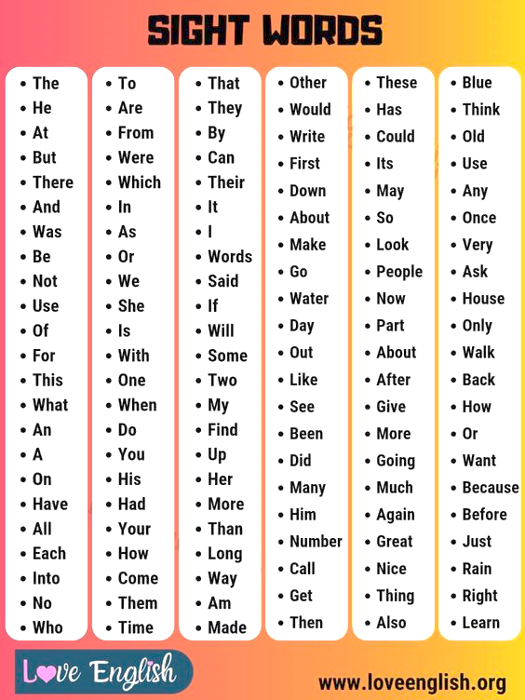
English

These sight words needs to be read and learn every day.

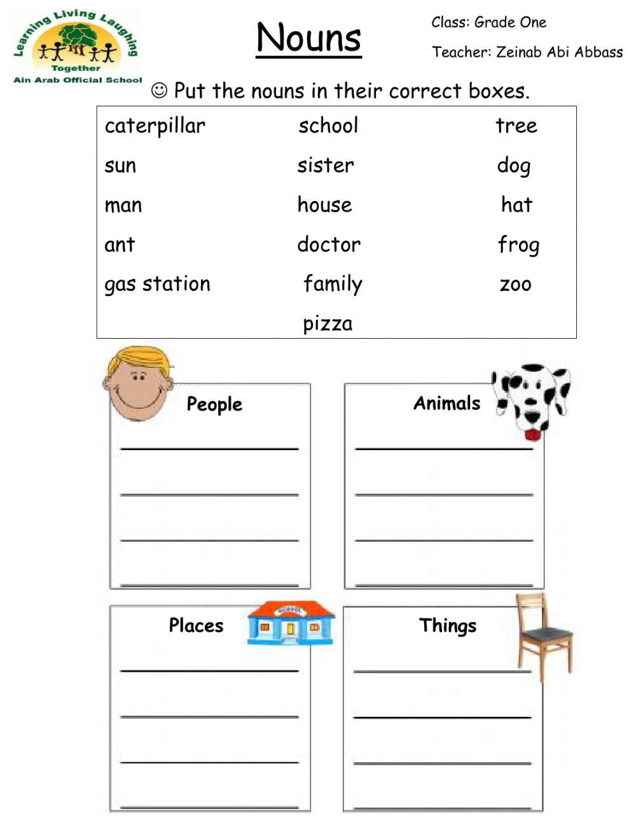

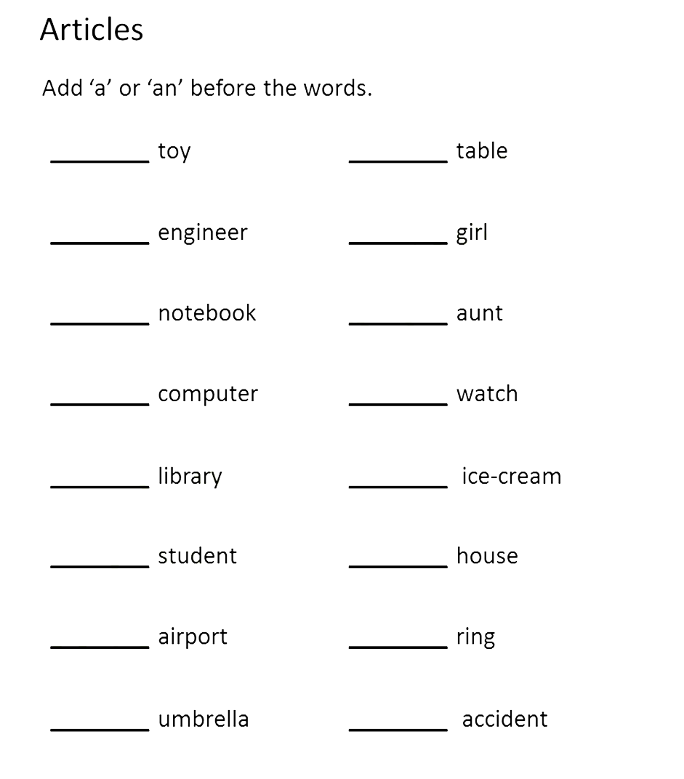

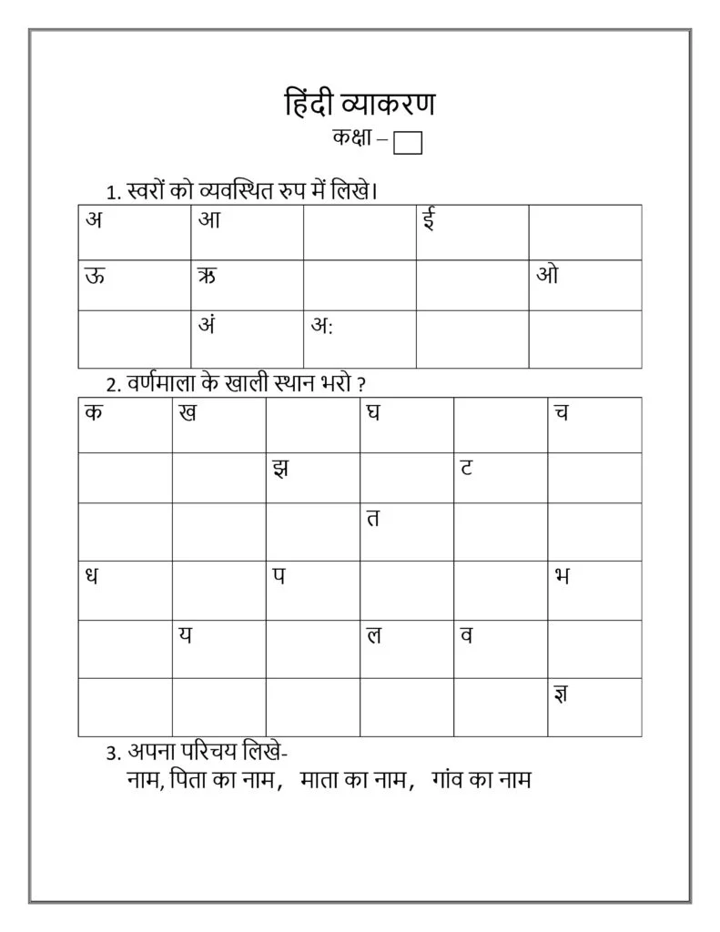
Hindi

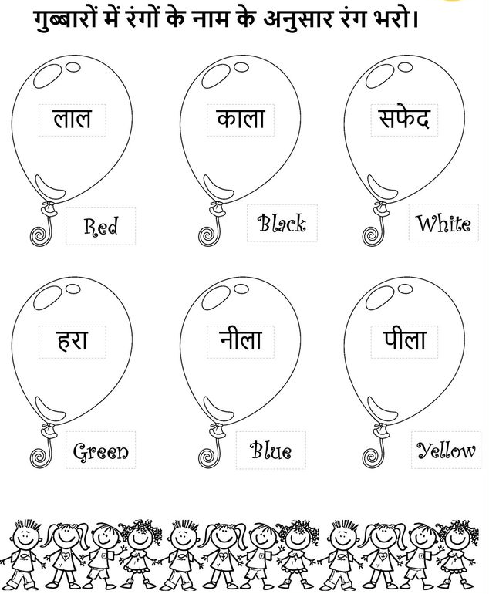

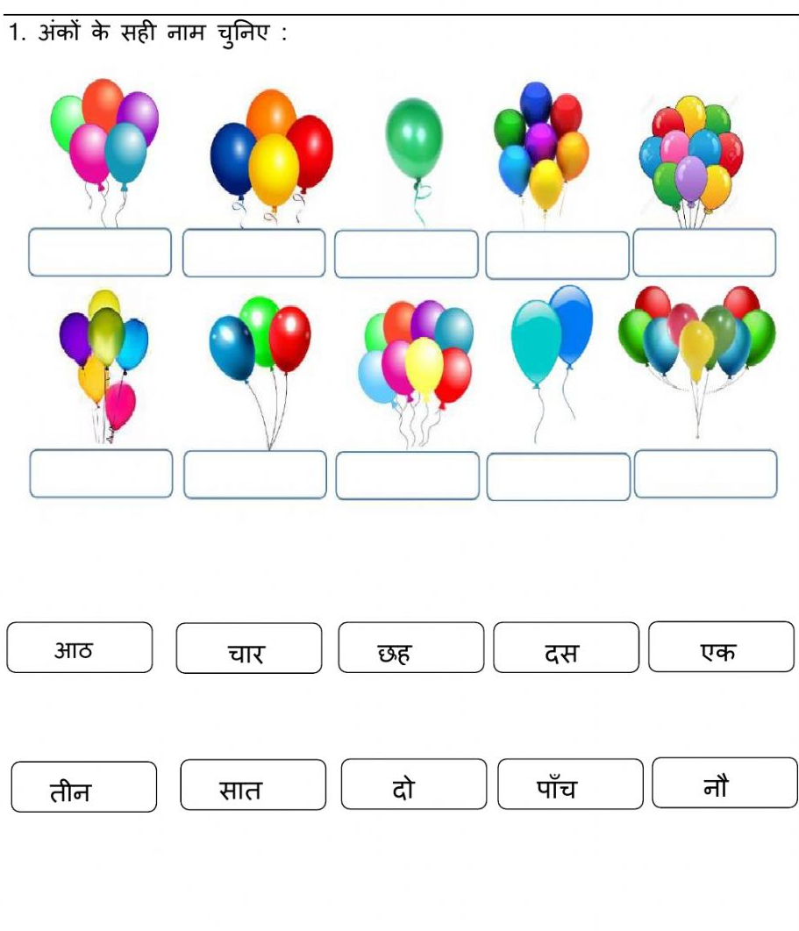

EVS

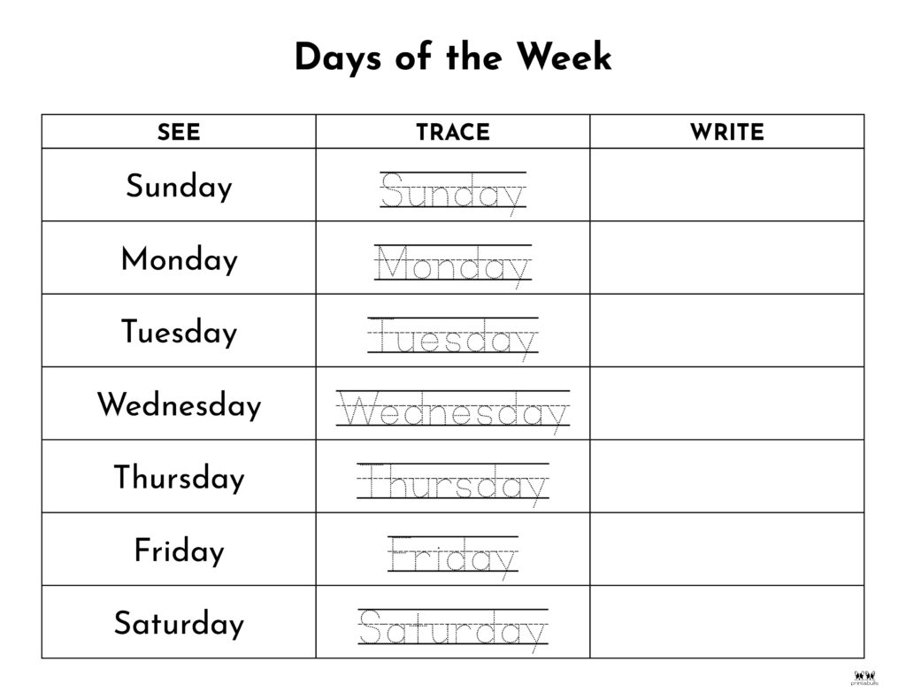

Self-introduction needs to be learnt

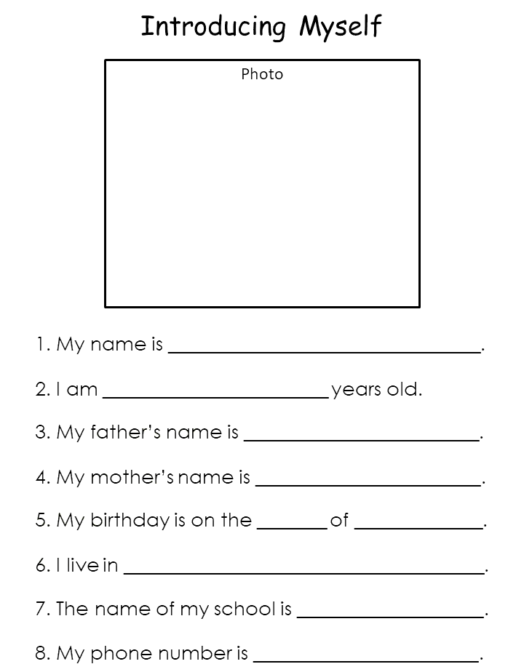

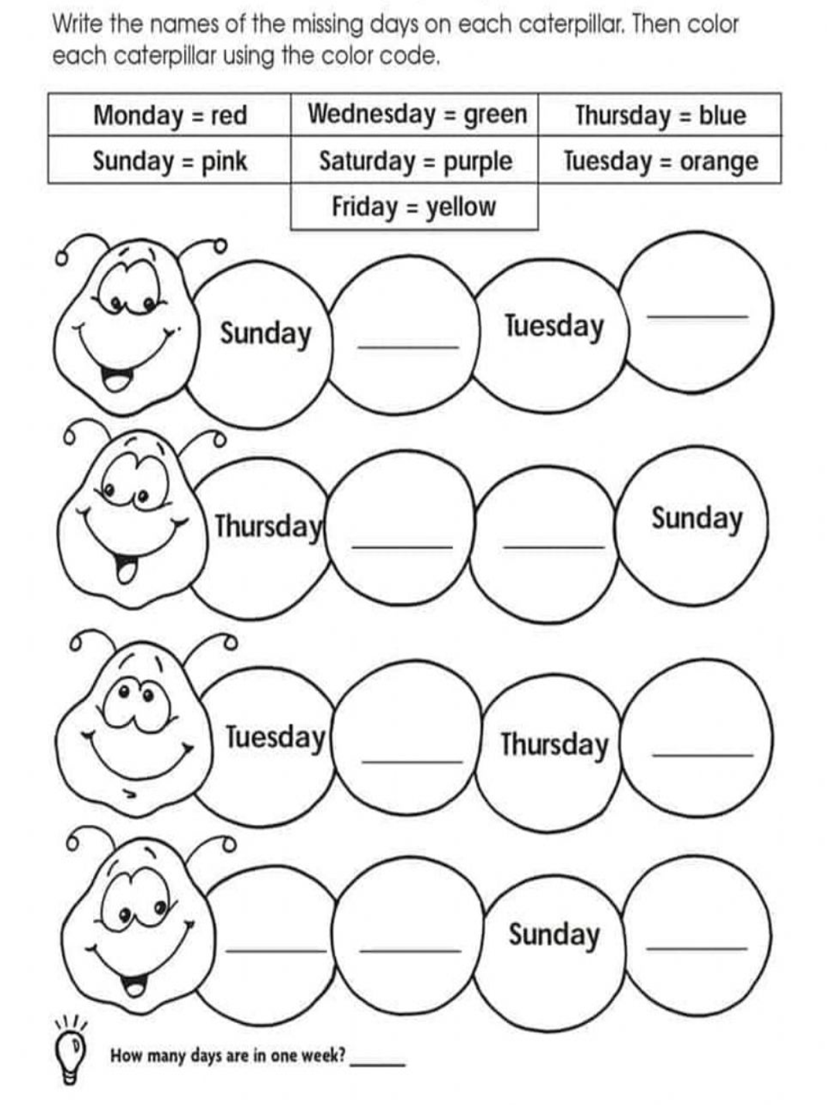

Maths

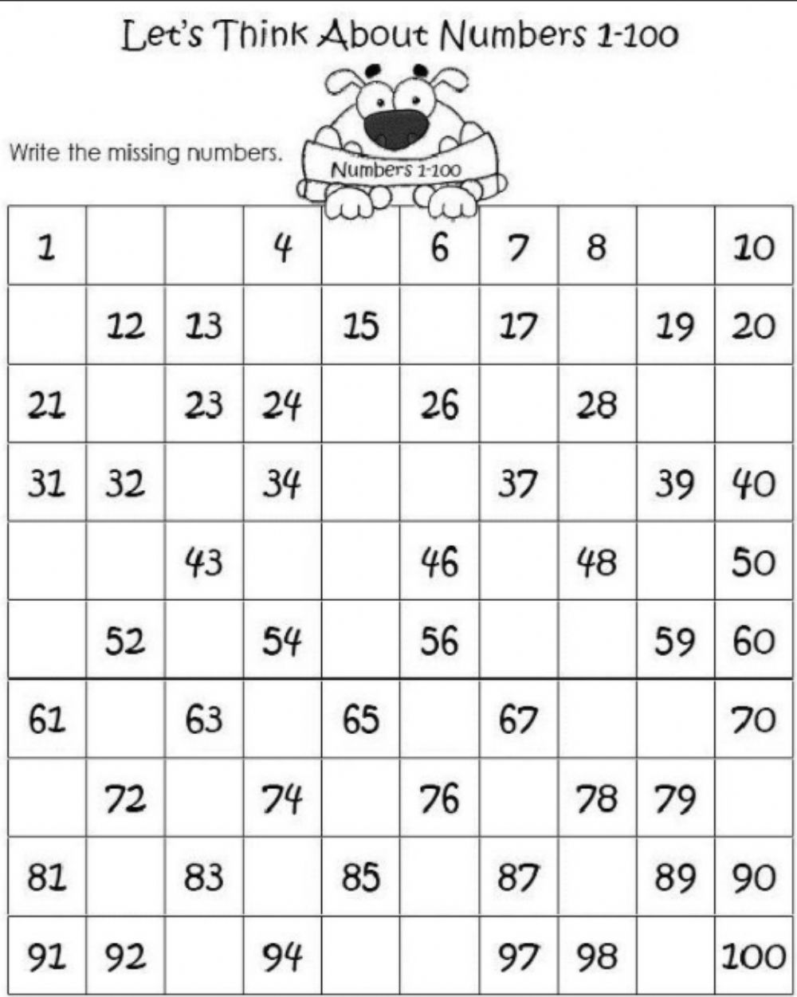

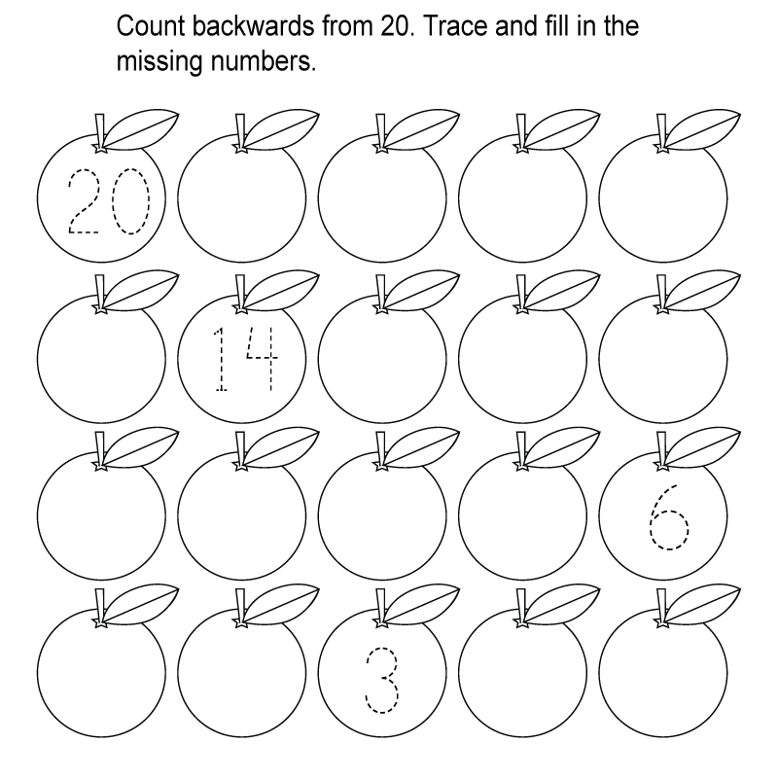

Write numbers name for the given numbers.
1 ____________________ 21 ___________________
2 ____________________ 22 ___________________
3 ____________________ 23 ___________________
4 ____________________ 24 ___________________
5 ____________________ 25 ___________________
6 ____________________ 26 ___________________
7 ____________________ 27 ___________________
8 ____________________ 28 ___________________
9 ____________________ 29 ___________________
10 ____________________ 30 ___________________
11 ____________________ 31 ___________________
12 ____________________ 32 ___________________
13 ____________________ 33 ___________________
14 ____________________ 34 ___________________
15 ____________________ 35 ___________________
16 ____________________ 36 ___________________
17 ____________________ 37 ___________________
18 ____________________ 38 ___________________
19 ____________________ 39 ___________________
20 ____________________ 40 ___________________
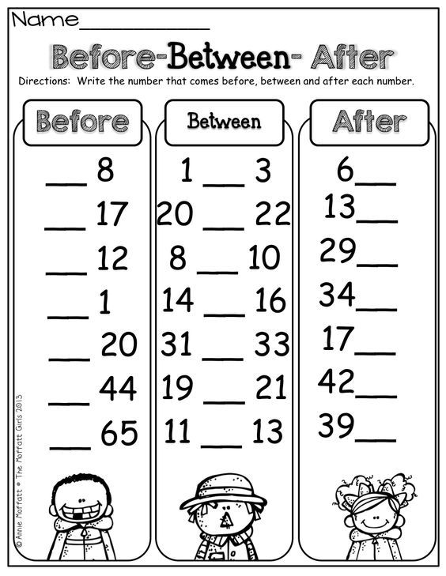

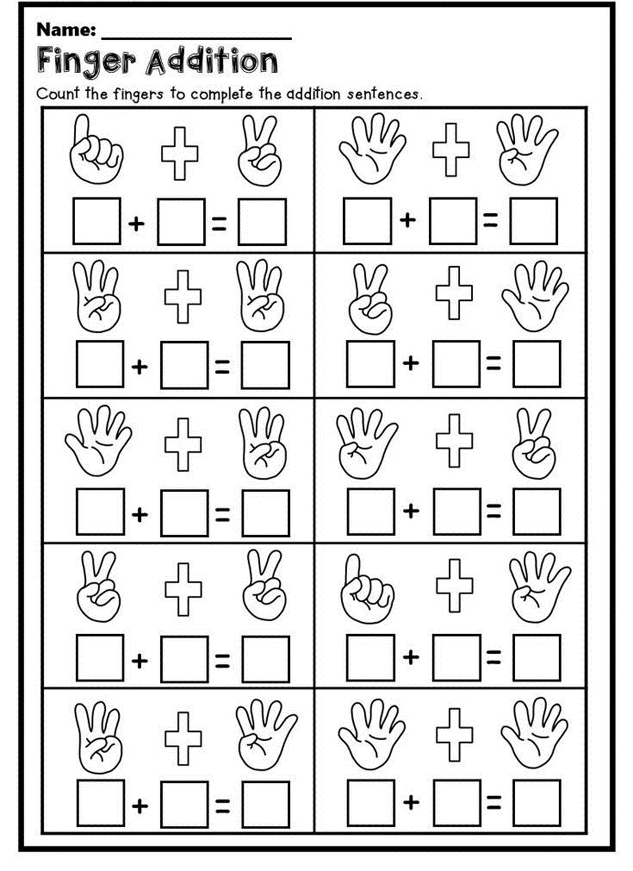

Here are some fun loving activities to be done during these holidays…
- Prepare an image using different shapes.
Example given below (to be done in A4 sheet by pasting different shapes)
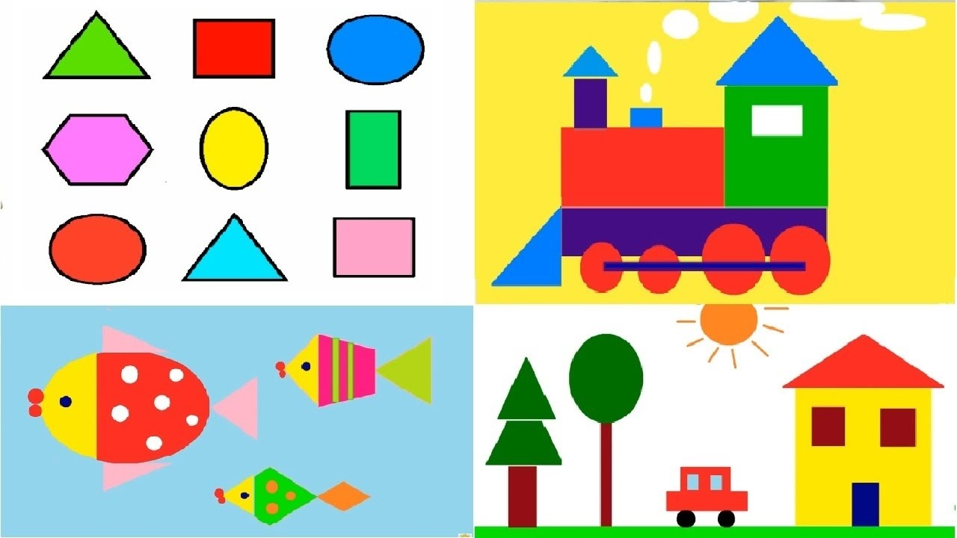

- Practice tying shoe laces all by yourself…

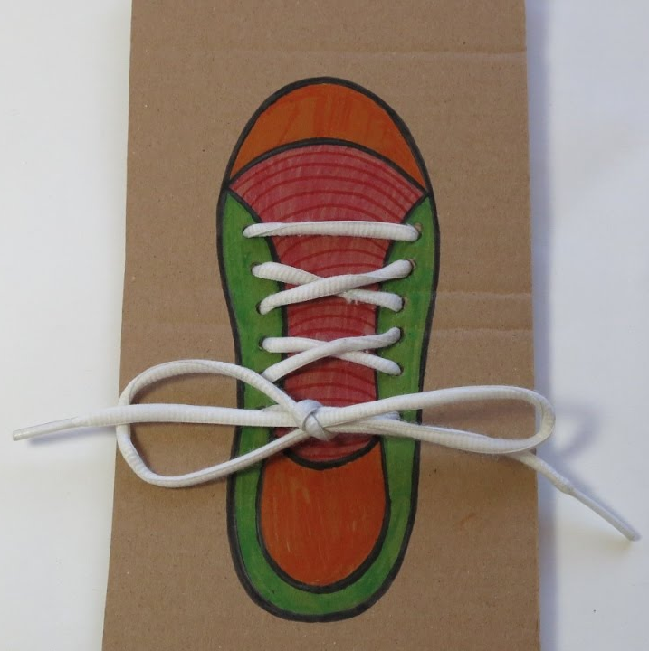
Learning is fun!!!

